# Task

You have been tasked with creating a showcase of your learning. Your showcase will use the focus on a Tool of Learning, the TryHackMe website, to learn different aspects of cyber security. The default showcase will be an A2 poster of your learning and one recorded presentation for a general audience.

# Tool of learning

The focus of this body of work **will be using** [**TryHackMe**](https://tryhackme.com/)**.** TryHackMe is an online platform that teaches cyber security through short, gamified, real-world labs.

TryHackMe has a free account. However, it limits the number of available learning paths and how many hours a day you can spend on the attack box (**1 hour a day**). **You will need to do some work daily** to complete enough of the work to move forward. It is impossible to cram this in at the last minute.

# Tasks for learning and submission

Your in-class activities are to complete a range of rooms from Try Hack Me. You have to complete at least six rooms. Students from 2021 who completed some of these tasks need to complete new tasks. Students who’ve completed all of these tasks elsewhere can negotiate a secondary task.

You must complete

* Tutorial - https://tryhackme.com/room/tutorial
* Starting Out In Cyber Sec - https://tryhackme.com/room/startingoutincybersec
* Introductory Researching - https://tryhackme.com/room/introtoresearch

Complete 5+ of the following Sections/Rooms

* Linux Fundamentals Part 1 - https://tryhackme.com/room/linuxfundamentalspart1
* Linux Fundamentals Part 2 - https://tryhackme.com/room/linuxfundamentalspart2
* Linux Fundamentals Part 3 - https://tryhackme.com/room/linuxfundamentalspart3
* Introductory Networking - https://tryhackme.com/room/introtonetworking
* Nmap - https://tryhackme.com/room/furthernmap
* HTTP in detail - https://tryhackme.com/room/httpindetail
* Burp Suite: The Basics - https://tryhackme.com/room/burpsuitebasics
* OWASP Top 10 - https://tryhackme.com/room/burpsuitebasics
* OWASP Juice Shop - https://tryhackme.com/room/owaspjuiceshop
* Pickle Rick - https://tryhackme.com/room/picklerick

NOTE: some of these components will consume a lot more time than others. Do not assume they are all easy mode 😊

You are required to show evidence of completion. Ideally, this should be

screenshots of your completed sections.

# Showcase Responses

Your poster and presentations must respond to three statements and present different levels of information to describe what it is you learnt and how that knowledge can be used in cyber security.

The statements will be provided in the rubric below. You must address your responses to the three audiences:

1. Poster – summarise your learning for general audiences in a condensed writing environment
2. General audience presentation – simulates presenting your work and learning to a general audience and allows for some extrapolation

Your general audience presentation should be no more than 5 minutes.

##### Section 1: Knowledge Comprehension, and Application

This section of the rubric consists of the required elements of the assignment. Students should take special care to include ALL these elements as they are often extended in the following sections

##### Section 2: Analysis, Synthesis, and Evaluation.

This section will evaluate your ability to include critical thinking and justification elements into your work. Often the requirements for extension are not explicitly given, so it will be up to the you to decide how best to demonstrate what you have learned beyond the required unit goals and curriculum. Items such as 3D models, pictures, drawings, diagrammatic responses, notes, evidence of problem solving, advanced programming concepts, elegant responses, media, etc., are all available options.

##### Section 3: Submission Guidelines

For this section, students will be expected to provide a submission which fulfills all of the formatting and citation requirements listed in this assessment sheet but also that the submission is of a professional quality. Be aware, points in this section could be 2- or 4-point items. Treat them accordingly.

## Submission

All submission items should be stored in an appropriate format. For example, code must be stored in a programmatical format so it can be evaluated (**images of code, or code simply copied and pasted into a document, will not be marked**)

Evidence of working material must be recorded where appropriate. For example, if you are showing how your game meets some requirement, you must submit a recording. Similarly, if you are showing how your robot meets a requirement, you must record it.

If you are unsure if an element needs to be recorded, **ask the teacher.**

All materials must be submitted to google classrooms.

Students are responsible for keeping backups/master-copies.

## **Scoring Notes**

Formatting for all typed/written assessments should be as follows:

|  |  |  |  |  |  |  |
| --- | --- | --- | --- | --- | --- | --- |
| **Google Doc** | 11-12 Pt | 1.15-1.5 Line Spacing | 1 Space between paragraphs | Spelling and Grammar “Soft Limit” | In-Text Citations with footnotes | Title Page/Slide:   * Name * Date * Class * Aim * Assessment title |
| **Slides** | 10-12 pt. font text  14-24 pt. font titles | 1.0 1.15 Line Spacing | Bullet Points Preferred | Word Count per slide >100-110 “Soft Limit” | Approved Templates and Themes |
| **Python** | We apply the following style guide to Python files. However, in general most programs follow this broad layout.    [PEP 8: The Style Guide for Python Code](https://pep8.org/) | | | | | |
| **Arduino**  **C/C++** | We apply the following style guide to C/C++ files. However, in general most programs follow this broad layout.    I accept both K&R and K&R alternative bracing format. As long as it is consistent in your file.  [Arduino Style Guide for Creating Libraries | Arduino Documentation | Arduino Documentation](https://docs.arduino.cc/learn/contributions/arduino-library-style-guide) | | | | | |
| **Markdown** | We apply the following style guide to markdown documents. However, in general, most documents follow some variation of the following layout:    <https://github.com/google/styleguide/blob/gh-pages/docguide/style.md> | | | | | |

“Soft Limits” are not rigidly defined limits and will be assessed on a case-by-case basis. Ask for clarification for specific tasks

## Possible Scoring Groups are out of 2 or 4 Points.

**2-Point Criteria - Knowledge and Understanding**

Criteria assessed as 2-Points are classified as Knowledge and Understanding criteria. These will examine and evaluate a student’s ability to state facts and define terms and concepts effectively. Analysis and synthesis of the information will not be assessed through these criteria.

|  |  |  |  |
| --- | --- | --- | --- |
|  | **0 Points** | **1 Point** | **2 Points** |
| **2 Point Criteria** | **Not present** or **not able to be assessed** as the required criteria | Item is presented but **does not meet expectations** for quality, rigour, or detail. | Item is presented and **does meet expectations** for quality, rigour, or detail |

**4-Point Criteria - Analysis and Synthesis and Expert Review**

To show true mastery of your developing skills, students must show that they can go beyond simple repetition of the given tasks or an explanation of processes. Students will show their ability to show higher order thinking through analysis, evaluation, or the linking of multiple fields of learning to solve problems in novel ways.

**Analysis and Synthesis**

Analysis and Synthesis components evaluate a student’s ability to effectively review data and understandings and develop these into a coherent and relevant statement. Analysis refers to the generating of thoughts from interpreting the data, while synthesis refers to combining analysis of the data with other relevant information to develop an original and effective idea.

|  |  |  |  |  |  |
| --- | --- | --- | --- | --- | --- |
|  | **0 Points** | **1 Point** | **2 Points** | **3 Points** | **4 Points** |
| **4 Point Criteria** | **Not present** or **not able to be assessed** as the required criteria | Item is presented and explained. However, it **does not show appropriate evidence of higher order thinking** such as analysis, evaluation, or synthesis. | Item is presented and **shows appropriate evidence of higher order thinking** such as analysis, evaluation, or synthesis. | Item is presented and **exceeds expectations for evidence of higher order thinking** such as analysis, evaluation, or synthesis.  **-or-**  Item is presented and shows appropriate evidence of higher order thinking such as analysis, evaluation, or synthesis and **exceeds expectations for quality or rigour**, of understanding of the selected mastery. | Item is presented and **exceeds expectations for evidence of higher order thinking** such as analysis, evaluation, or synthesis. **Additionally, this item exceeds expectations for quality or rigour**, of understanding of the selected mastery. |

**Expert Review**

Expert Reviews evaluate a student’s ability to build solutions using the skills that have been taught during the semester. Criteria assessed as 4-Points are classified as Analysis and Synthesis criteria. These will examine and evaluate a student’s ability to effectively review data and understandings and develop these into a coherent and relevant statement. Analysis refers to the generating of thoughts from interpreting the data, while synthesis refers to combining analysis of the data with other relevant information to develop an original and effective idea.

|  |  |  |  |  |  |
| --- | --- | --- | --- | --- | --- |
|  | **0 Points** | **1 Point** | **2 Points** | **3 Points** | **4 Points** |
| **4 Point Criteria** | **Not present** or **not able to be assessed** as the required criteria | Item is presented and broadly solves the problem. However, upon review, it **does not show enough evidence of appropriate mastery**. | Item is presented and broadly solves the problem. On review, it **does show appropriate evidence** of mastery. | Item is presented and solves the specific problem. On review, the evidence **shows understanding beyond expected mastery**.  **-or-**  Item is presented and broadly solves the problem. On review, it does show appropriate evidence of mastery and is **done so in a well-constructed or design method** that clearly shows higher levels of understanding**.** | Item is presented and solves the specific problem. On review, **the evidence shows understanding well beyond expected mastery** and is **done so in a well-constructed or design method** that clearly shows higher levels of understanding. |

**Multiplier**

Criteria will be combined with a **Multiplier**. While each criterion will be scored on the 0-1-2-4 scale, the multiplier will attach relevant worth to each criterion. Be aware of these multipliers and dedicate appropriate time to ensure you achieve your best result.

**Achievement Standards:**

##### Evidence of higher order learning:

What is it that I mean by “higher order thinking”?

It means I want you to go beyond just replicating what we do in class. I want you to dig into your brain and understand why you did something, what about it was great, what could be improved.

Why is this important? Reflective thinkers can go beyond what they are taught and can customise their learning to ben

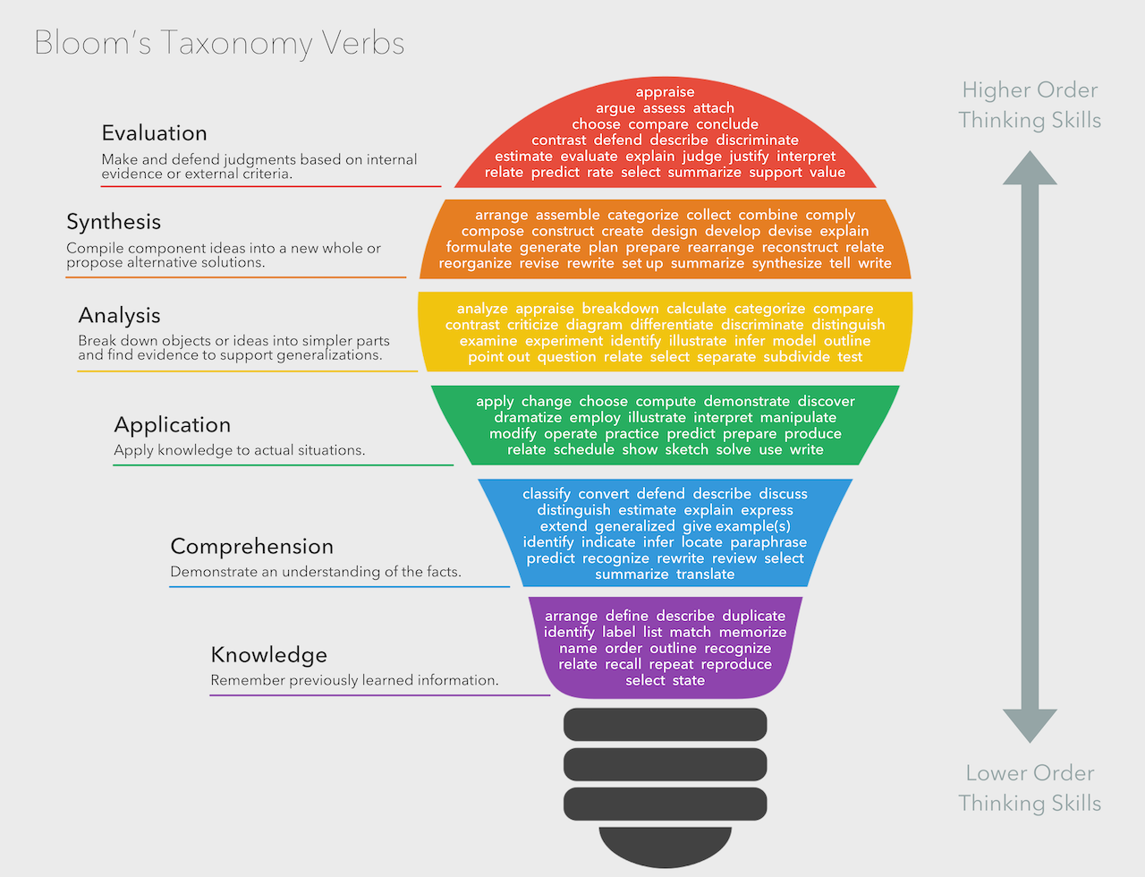

## Rubric

|  |  |  |  |  |  |  |
| --- | --- | --- | --- | --- | --- | --- |
|  | **Knowledge, Comprehension & Application** |  |  |  |  |  |
| **CRITERIA** | **EXPECTATIONS** | **POSS** | **STUDENT** | **GIVEN** | **MULTI** | **TOTAL** |
| **TryHackMe Sections** | You have submitted **evidence of completing each of the required sections of TryHackMe**. This evidence can be presented as screenshots of completion.  **There is evidence of the compulsory of the following submissions**:   * Tutorial | Starting out in cyber security | Introductory Researching   You have also submitted **evidence of the 5+ of the following rooms** (or negotiated equivalent)   * Linux Fundamentals 1 * Linux Fundamentals 2 * Linux Fundamentals 3 * Introductory Networking * Nmap * HTTP in detail * Burp Suite * OWASP Top 10 * OWASP Juice Shop * Pickle Rick   Evidence for knowledge, comprehension, and application may include:   * **Knowledge**: Your evidence highlights that you recall and list relevant terms covered in your learning. It may tell a story to the reader (the teacher) or state your learning conditions. * **Comprehension**: Your evidence highlights that you can identify key aspects of your learning or explain what you've done to the author. * **Application**: It is clear from your evidence that you constructed a complete submission | 2  ---  2  2  2  2  2 | __/2  --- __/2 __/2  __/2 __/2 __/2 | __/2  --- __/2 __/2  __/2 __/2 __/2 | A x2  T x1 | A __/ 24  T __/ 12 |
| **Showcase** | You have submitted evidence of completing the required assessment material. This evidence is presented in an appropriate format unless negotiated otherwise.  There is evidence of the following submissions:   * A poster that answers all three questions for a general audience * A spoken presentation of the poster for general audiences   Evidence for knowledge, comprehension, and application may include:   * **Knowledge**: Your evidence highlights that you recall and list relevant terms covered in your learning. It may tell a story to the reader (the teacher) or state your learning conditions. * **Comprehension**: Your evidence highlights that you can identify critical aspects of your learning or explain what you've done to the author. * **Application**: It is clear from your evidence that you constructed a complete submission | 2  2 | __/2 __/2 | __/2 __/2 | - | __/ 4 |
|  | **Analysis, Synthesis & Evaluation** |  | | **SUB TOTAL** | | **A _ / 28**  **T _ / 16** |
| **Question 1** | **Statement**: What is offensive security, and why is it essential for learners to work offensively? Provide examples of offensive security techniques in your discussion.  Learning how to break things is fun but is there an educational benefit in doing it? Apply your learning and understanding of industry and the potential future to tell people why what we do in this class is essential for education.  Statement responses are used to evaluate your ability to **analyse your learning**, identify **how and when you synthesised new understanding** on your own, and your ability to **reflect upon your work**  Showcases are a tool **you use to highlight your learning to different audiences**. Learning how to **reflect on what you learnt** during your assessments and **identifying** what parts of your work were **high quality** and what you could do **to improve** your work is an **essential aspect of education**.  This question will be marked against the following aspects of your ability to:   * To **summarise your understanding of technology** concepts and principles to a general audience * express **your understanding of technology** concepts and principles to a general audience * **your ability to communicate your learning** appropriately to experts   Evidence for higher-order learning may include:   * **Analysis**: Your evidence shows a reasoned understanding of what you did and why. For example, you may have explained how you did X, Y, and Z, but you continue to explain why you did them the way you did. * **Evaluative**: your evidence makes a judgement of something or between multiple things. This judgement may be the value of one thing over another or highlighting the significant differences between two things. * **Transferal**: your evidence highlights when you apply information, strategies, or skills that you have learnt to a new situation or context. | 4 | __/4 | __/4 | - | __ / 4 |
| **Question 2** | **Question**: What are some ethical considerations that we need to take regarding learning cyber security? Provide examples of what learners and teachers should consider in the education of young people in cyber security  Learning to break things is fun, but education isn't always focused on fun. How can young people get themselves into strife online, and what can we do to protect them?  Statement responses are used to evaluate your ability to **analyse your learning**, identify **how and when you synthesised new understanding** on your own, and your ability to **reflect upon your work**  Showcases are a tool **you use to highlight your learning to different audiences**. Learning how to **reflect on what you learnt** during your assessments and **identifying** what parts of your work were **high quality** and what you could do **to improve** your work is an **essential aspect of education**.  This question will be marked against the following aspects of your ability to:   * To **summarise your understanding of technology** concepts and principles to a general audience * express **your understanding of technology** concepts and principles to a general audience * **your ability to communicate your learning** appropriately to experts   Evidence for higher-order learning may include:   * **Analysis**: Your evidence shows a reasoned understanding of what you did and why. For example, you may have explained how you did X, Y, and Z, but you continue to explain why you did them the way you did. * **Evaluative**: your evidence makes a judgement of something or between multiple things. This judgement may be the value of one thing over another or highlighting the significant differences between two things. * **Transferal**: your evidence highlights when you apply information, strategies, or skills that you have learnt to a new situation or context. | 4 | __/4 | __/4 | - | __ / 4 |
| **Question 3** | **Question**: How do hackers attack networks? Provide examples and document why it is important to understand why learners must study how to build and attack networks?  Show people what you've learnt on TryHackMe. Why is this a relevant skill? How can it be deployed?  Statement responses are used to evaluate your ability to **analyse your learning**, identify **how and when you synthesised new understanding** on your own, and your ability to **reflect upon your work**  Showcases are a tool **you use to highlight your learning to different audiences**. Learning how to **reflect on what you learnt** during your assessments and **identifying** what parts of your work were **high quality** and what you could do **to improve** your work is an **essential aspect of education**.  This question will be marked against the following aspects of your ability to:   * To **summarise your understanding of technology** concepts and principles to a general audience * express **your understanding of technology** concepts and principles to a general audience * **your ability to communicate your learning** appropriately to experts   Evidence for higher-order learning may include:   * **Analysis**: Your evidence shows a reasoned understanding of what you did and why. For example, you may have explained how you did X, Y, and Z, but you continue to explain why you did them the way you did. * **Evaluative**: your evidence makes a judgement of something or between multiple things. This judgement may be the value of one thing over another or highlighting the significant differences between two things. * **Transferal**: your evidence highlights when you apply information, strategies, or skills that you have learnt to a new situation or context. | 4 | __/4 | __/4 | - | __ / 4 |
| **Audio Presentation** | **You have submitted evidence of a presentation**. This presentation is **intended to be spoken** but can be negotiated. The presentation elevates the poster **by providing additional information via extrapolation** of the facts included in the poster.  **The presentation is not long**. No more than 5 minutes. You pitched your **presentation as if it could replace a physical showcase**. The production recording itself is not being assessed; instead, you will **be evaluated on your ability to extrapolate and expand your content** to expand the significant points to provide more details briefly.  Showcases are a tool **you use to highlight your learning to different audiences**. Learning how to **reflect on what you learnt** during your assessments and **identifying** what parts of your work were **high quality** and what you could do **to improve** your work is an **essential aspect of education**.  This question will be marked against the following aspects of your ability to:   * To **summarise your understanding of technology** concepts and principles to a general audience * express **your understanding of technology** concepts and principles to a general audience * **your ability to communicate your learning** appropriately to experts   Evidence for higher-order learning may include:   * **Analysis**: Your evidence shows a reasoned understanding of what you did and why. For example, you may have explained how you did X, Y, and Z, but you continue to explain why you did them the way you did. * **Evaluative**: your evidence makes a judgement of something or between multiple things. This judgement may be the value of one thing over another or highlighting the significant differences between two things. * **Transferal**: your evidence highlights when you apply information, strategies, or skills that you have learnt to a new situation or context. | 4 | __/4 | __/4 | A x1  T x2 | A __ / 4  T __ / 8 |
|  | **Submission Guidelines** |  | | **SUB TOTAL** | | **A __/16**  **T __/20** |
| **Readability** | **Assessment submission is ordered** and has a definite pattern to its construction. **The reader is not confused about the content in any given section and can easily follow the submission flow**. | 4 | __/4 | __/4 | X2 | __ / 8 |
| **Formatting** | **Students have** **followed the formatting instructions**, including any provided templates and guides, or **created their** legible formatting guide **and applied it constantly**. | 2 | __/2 | __/2 | - | __ / 2 |
|  |  |  | | **SUB TOTAL** | | **__ /10** |
|  | DAYS LATE ___/7 = ___% |  |  | **FINAL** | | **A __/54 T __/46** |

## VET Competencies

|  |  |  |  |
| --- | --- | --- | --- |
| Result | Vocational competencies assessed via this task | | Aspect of task addressing competency |
|  | BSBOHS201A | Participate in OHS processes | Proper use of equipment & evacuation drills |
|  | ICAICT202A | Work and communicate effectively in an IT environment | Researching, creating, printing & submitting of Research Report |
|  | ICAICT201A | Use Computer Operating System and Hardware | Participation in organised IT activity & researching & creating report |